**Group Meeting 1 (09/26)**

**Project 1:** Modernize the corporate C codebase by converting it into programming languages such as Java, Python, and .NET.

* **Method 1:** Create a new system supported by a backend functionality: **(Maximo Sanchez)**
  + **Pros:** Demonstrates promising potential for deployment of a user-friendly website that supports the functionality of Project 1. Can be connected to their UNIX cloud service and tested in a demo database that would not tamper with their production data.
  + **Cons:** Requires a corporate level of established UNIX support. Can take some time to adapt all their fields into a database.
* **Method 2:** Use Hugging Face Transformers *TransCoder* to convert C to Python. **(Youssif Goda)**
  + **Pros:** Easiness to follow the protocol
  + **Cons:** Lacking resources other than example codes in the open source.

**Project 2:** Scan the corporate codebase and produce documentation and specifications that can facilitate training new developers.

* **Approach 1:** Construct an automated Pipeline Construction **(John Chu + Pranav Mishrav)**

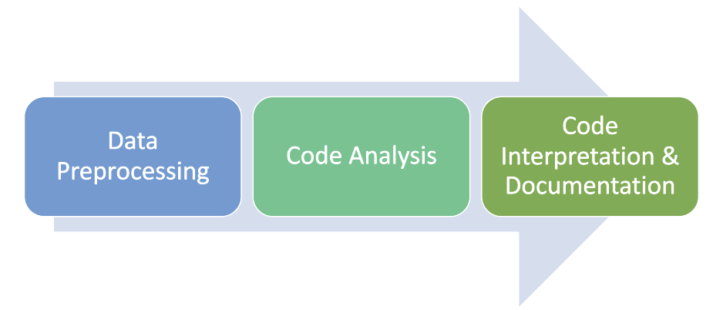

* + **Pros:** robust operation and less costly.
    - In the long run, we do not need to rely on Codepilot or external software.
  + **Cons:** takes a huge amount of time and implicate the long-term project.
    - Requirement of algorithms that separate useful information from irrelevant data, white space, and comments.